INFERENTIAL STATISTICS

Inferential statistics is a branch of statistics that allows you to draw conclusions or make predictions about a population based on a sample of data.
In simple words:
You collect a small amount of data (sample).
You analyse it.
You make conclusions or predictions about the larger group (population).

Why do we use inferential statistics?
Because it is impossible or impractical to study an entire population, so we use a sample and infer the results.

Common techniques in inferential statistics
- Hypothesis testing (t-test, chi-square test, ANOVA)
- Confidence intervals
- Regression analysis
- Correlation analysis
- Estimating population parameters

Example
1.If you survey 100 students from a college to estimate the average height of all students, you are using inferential statistics.
2.e-commerse sector
POPULATON AND SAMPLE
A population is the entire group of individuals, items, or events that you want to study or draw conclusions about.
It includes every member of the group.
It is usually large and sometimes impossible to measure completely.
Example:
All students in a university, all customers of Amazon, all people in India.
A sample is a small subset of the population that you actually collect data from.
It is a part of the population.
It is used because studying the whole population is difficult.
Example:
100 students selected from the university, 500 Amazon customers surveyed, 1,000 people chosen from India.

Sample-------infer------population

SAMPLING
Sampling is the process of selecting a small group (sample) from a large group (population) so that you can study the sample and draw conclusions about the entire population.
TYPES OF SAMPLING TECHNIQUES
1.PROBABILITY SAMPLING
In probability sampling,every individual in the population has a known and equal chance of being selected.this ensures that the sample is unbiased and representative.
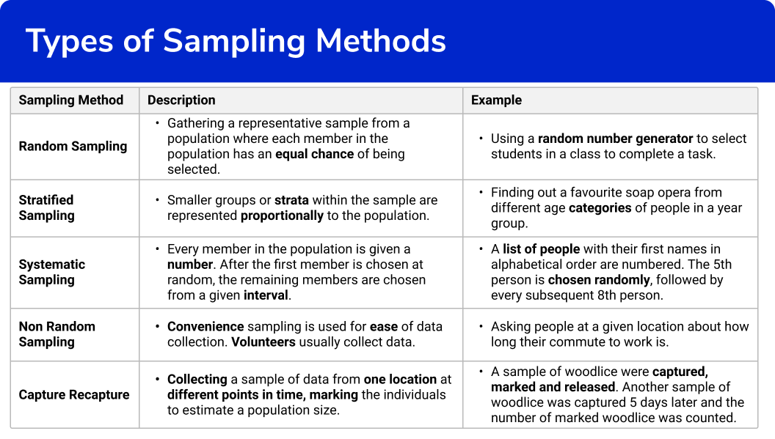
CENTRAL LIMIT THEOREM
One of the most fundamental concepts in statistics and serves as the backbone for many statistical and machine learning methods.
The Central Limit Theorem states that when you take many random samples from any population and calculate their means, the distribution of those sample means will be approximately normal (bell-shaped) — even if the original population is not normal — as long as the sample size is large enough (usually n ≥ 30).
Note:all samples from a population must contain same no.of observations
In practice,data often comes from distributions that are skewed or irregular(eg:income data,customer purchase patterns etc).the clt allows us to bypass the complexity of these distributions by working with the sampling distribution of the mean,which approximates a normal distribution.
DATA AND ITS TYPES
1.numerical
2.categorical

1.NUMERICAL :made of numbers
Eg:age,weight,number of students,shoe size etc
a)continuous :infinite options
height,weight,bp
b)discrete:finite options
shoe size,no.of children
2.CATEGORICAL:made of words
a)ordinal :data has a hierarchy
school levals,student grade,pain severity,satisfaction
b)nominal:data has no hierarchy
eye color,dog breed,blood type
BOOTSTRAPPING
A sampling technique used to estimate statistics (like mean ,median) from a small dataset by randomly sampling with replacement.
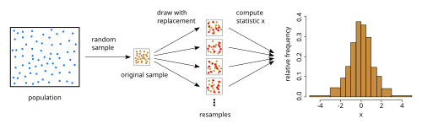
• You start with your original sample data.
• You create many new “bootstrap samples” by randomly selecting data points with replacement (so the same data point can appear multiple times).
• For each bootstrap sample, you compute a statistic (mean, median, etc.).
• The collection of these statistics forms a bootstrap distribution, which helps estimate uncertainty, standard errors, and confidence intervals.
Eg: [5,7,8,9]
Sample1 [5,5,8,7]
Sample2 [7,8,9,9]
Sample3 [8,8,8,5] etc
CONFIDENCE INTERVEL
A confidence level tells you how sure you are that your estimate (like mean or proportion) includes the true population value.
Eg:
You cant measure every student,so you take a sample
You find the sample mean=165 cm
But you know the real average might not be exactly 165-there is uncertainity.
So you create a confidence intervell ,say 160 cm to 170 cm.
Now it is 95 % confident that the actual average height lies between 160 cm and 170 cm.
That’s a 95 % confidence leval.
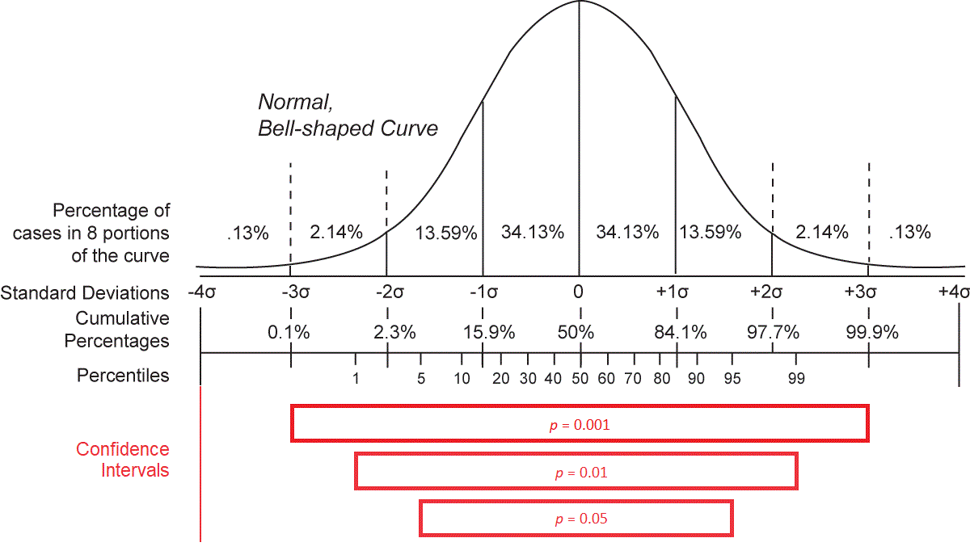

90%- if you repeated the study 100 times,90 of those intervels would contain the true value

95%-you are fairly confident-used in most scientific and academic research

99%-very high confidence,but your interval will be wider.
SIGNIFICANCE LEVAL
Significance level = the acceptable risk of making a wrong decision.
Significance level (α) is the probability of rejecting a true null hypothesis in hypothesis testing.
If the confidence level is 95% then significance level is 0.05
If the confidence leval is 90% then significance leval is 0.10
If the confidence leval is 99 % then significance leval is 0.01.
STANDARD ERROR
The standard error of the mean,indicates how different the population mean is likely to be from a simple mean.it tells you how much the sample mean would vary if you were to repeat a study using new samples from within a single population.
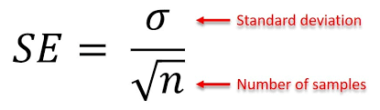
WHY STANDARD ERROR MATTERS
In statistics,data from samples is used to understand larger populations.standard error matters because it helps you estimate how well your sample data represents the whole population.
With probability sampling,where elements of a sample are randomly selected,you can collect data that is likely to be representative of the population.however even with probability samples,some sampling error will remain.
That’s because a sample will never perfectly match the population it comes from in terms of measures like means and standard deviations

Eg:
Class 8th has mean score of 40 out of 100.
The principal decided that extra classes are necessary in order to improve the performance of the class.the class scored an average of 45 marks out of 100 after taking extra classes.
Can we be sure whether the increase in marks is a result of extra classes or is it just random
HYPOTHESIS TESTING
Hypothesis testing lets us identify that.it lets a sample statistic to be checked against a population statistic or statistic of another sample to study any intervention etc.
Extra classes being the intervention in the above example.
Hypothesis testing is defined in two terms-null and alternate hypothesis.
NULL HYPOTHESIS:
The null hypothesis (H₀) is a statement in statistics that says there is no effect, no difference, or no relationship in the population.
Null hypothesis is the default assumption that nothing new or significant is happening.
H₀: The new teaching method does not improve student scores.
(marks are same before and after special class)
ALTERNATE HYPOTHESIS
The alternative hypothesis (H₁ or Ha) is the statement in hypothesis testing that says there is an effect, a difference, or a relationship in the population.
Alternative hypothesis is what you want to prove — it claims that something significant is happening.
H₁: The new teaching method improves student scores.
TESTS USED FOR REJECT HYPOTHESIS
z-tests,t-tests,chi-square tests
P VALUE
p-value is a number that helps you decide whether your results in hypothesis testing are statistically significant.
- A small p-value → strong evidence against the null hypothesis
- A large p-value → not enough evidence to reject the null hypothesis

Typical Rule
- If p-value < α (significance level, usually 0.05)
→ Reject the null hypothesis
- If p-value ≥ α
→ Fail to reject the null hypothesis
Eg:
Significance level=0.05
P value=0.03
Since 0.03<0.05,you reject null hypothesis
P value is not
1.the probability that H0 is true
2.the probability that H1 is true
3.the importance of the test
It only tells you whether the result is statistically significant.
POINT ESTIMATE AND INTERVEL ESTIMATE
A point estimate is a single value used to estimate an unknown population parameter
If you take a sample of 50 students and the average height is 160 cm, then:
- 160 cm is the point estimate of the average height of all students in the population.
An interval estimate is a range of values that is likely to contain the true population parameter.
It is usually expressed as a confidence interval.
TYPE 1 AND TYPE 2 ERRORS

Type I Error (False Positive)
You reject the null hypothesis when it is actually true.
Simple Meaning:
You think something significant happened, but actually nothing happened.

Example:
A test says a new drug works, but in reality, it does not.

Type II Error (False Negative)
You fail to reject the null hypothesis when the alternative hypothesis is true.
Simple Meaning:
You think nothing happened, but actually something did happen.

Example:
A test says a new drug does not work, but in reality, it works.

